**BRAC UNIVERSITY**

**DEPT. OF COMPUTER SCIENCE AND ENGINEERING**

**COURSE NO.: CSE250**

**Circuits and Electronics Laboratory**

**EXP. NO. 8**

**Name: Shihab Muhtasim**

**ID: 21301610**

**Name of the Experiment:**

STUDY OF TRANSIENT BEHAVIOR OF RC CIRCUIT (SIMULATION)

**OBJECTIVE:**

The objective of this experiment is to study the Transient Response of RC circuit with step Input. In this experiment, we shall apply a square wave input to an RC circuit separately and observe the respective wave-shapes and determine the time constants.

**Data Table:**

| Experimental | | | | | | | | | | | |
| --- | --- | --- | --- | --- | --- | --- | --- | --- | --- | --- | --- |
| No. of obs. | Input frequency (f) | Input time-period (ms) | R (measured)  (ohm) | C(used in the experiment)  (F) | Vin(amp) from signal generator (V) | Vin,rms (Multimeter in AC)  (V) | I rms  (Multimeter in series, AC)  (mA) | |z|  (ohm) | Vo,rms(Multimeter in AC) (V) | Vo(amp) (oscilloscope)  (V) | Phase difference = 360 f tdif (Degree) |
| 1 | 500 | 2 | 220 | 1uF | 4.99 | 3.53 | 9.133 | 386.9 | 2.009 | 2.841 | -55 |
| 2 | 1k | 1 | 220 | 1uF | 4.99 | 3.53 | 13.017 | 271.5 | 2.86 | 4.050 | -36 |
| 3 | 2k | 0.5 | 220 | 1uF | 4.99 | 3.53 | 15.08 | 233.9 | 3.319 | 4.69 | -20 |

| Theoretical | | | | | | | | | | | |
| --- | --- | --- | --- | --- | --- | --- | --- | --- | --- | --- | --- |
| No. of obs. | Input frequency (f) | Input time-period (ms) | R (ohm) | C | Vin(amp) (V) | Vin,rms  (V) | I rms  (mA) | |z|  (ohm) | Vo,rms (V) | Vo(V) | Phase difference (Degree) |
| 1 | 500 | 2 | 220 | 1uF | 5 | 3.53 | 9.1336 | 386.93 | 2.009 | 2.841 | -55.34 |
| 2 | 1k | 1 | 220 | 1uF | 5 | 3.53 | 13.017 | 271.53 | 2.86 | 4.050 | -35.88 |
| 3 | 2k | 0.5 | 220 | 1uF | 5 | 3.53 | 15.08 | 233.949 | 3.319 | 4.69 | -19.88 |

**Plot and Circuit Diagram:**

**500Hz**

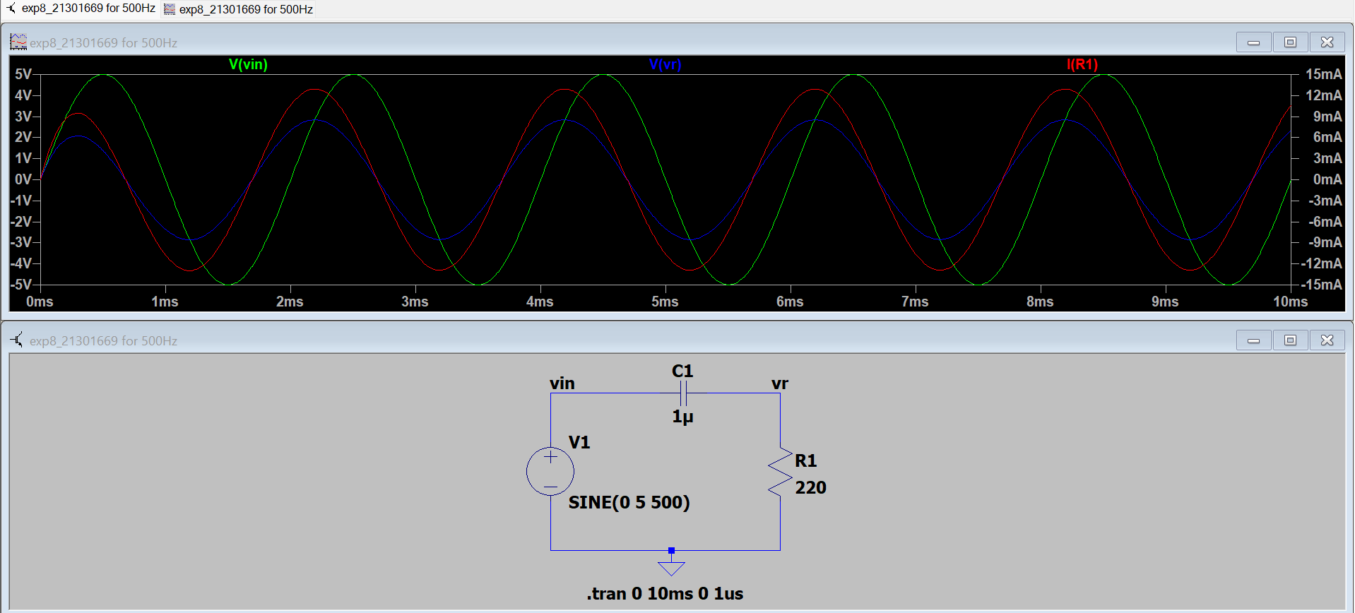

**1k Hz**

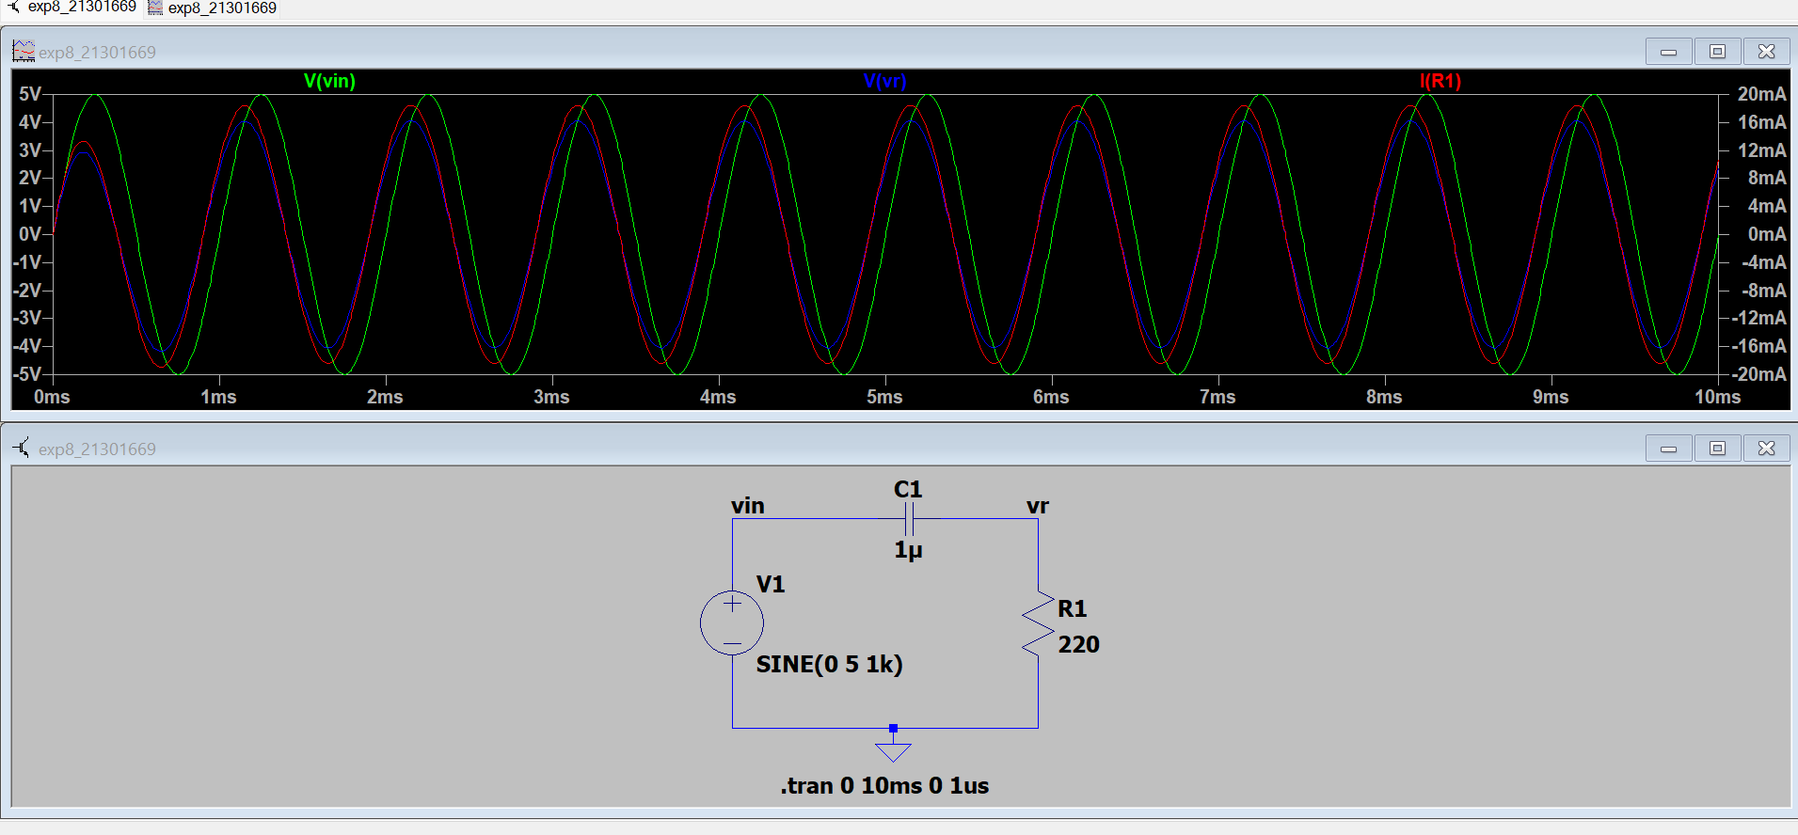

**2k Hz**

